MARI
Machine-Learning Aided Risk Intelligence

A Multilayered Uncertainty-Aware Framework
for Credit Card Fraud Detection

Devansh
Independent Researcher
2026

Table of Contents
1. Observation: Understanding the Data
2. Revelation: Why Simple Models Fail
3. Approach: Calibrated XGBoost & Uncertainty
4. Result: The 2D Risk-Uncertainty Decision Engine
5. Explainability: SHAP Analysis
6. Improvement: Novelty Detection & Calibration
7. Conclusion

1. Observation: Understanding the Data
We begin our investigation with a dataset of 284,807 European credit card transactions collected over two days in September 2013. The dataset contains 31 features: Time, Amount, and 28 PCA-transformed components (V1-V28), plus the binary Class label.
The defining characteristic of this dataset is extreme class imbalance:
Metric | Value
Total Transactions | 284,807
Legitimate | 284,315 (99.83%)
Fraudulent | 492 (0.17%)
Imbalance Ratio | 1 : 577
Mean Fraud Amount | $122.21
Mean Legit Amount | $88.29
Max Fraud Amount | $2,125.87
Max Legit Amount | $25,691.16

A naive model that approves every transaction achieves 99.83% accuracy while catching exactly zero fraud. This immediately tells us that standard accuracy is a useless metric for this problem.
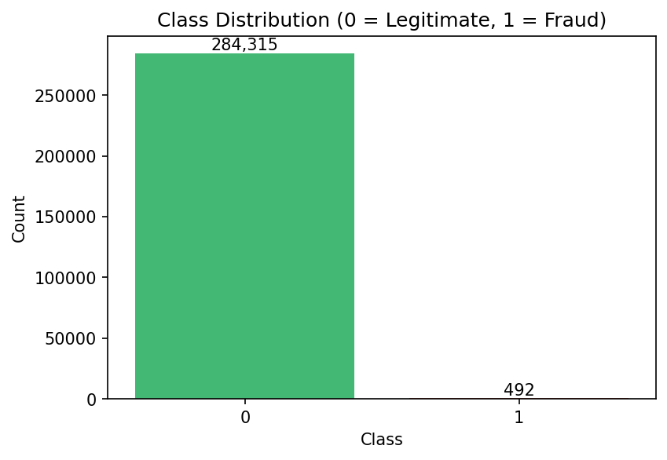
Figure 1: Class distribution showing extreme imbalance. The fraud bar (492 cases) is barely visible against 284,315 legitimate transactions.
Investigating the transaction amounts reveals that fraudulent transactions actually have a lower median ($9.25 vs $22.00) but higher mean ($122.21 vs $88.29). This suggests a bimodal pattern: fraudsters first test cards with small charges, then attempt larger exploitations.
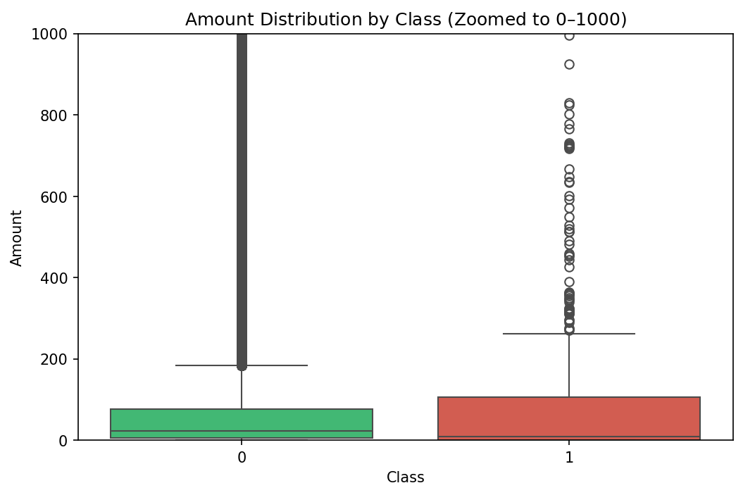
Figure 2: Amount distribution by class. Fraud amounts are concentrated lower but with a longer tail of high-value theft attempts.
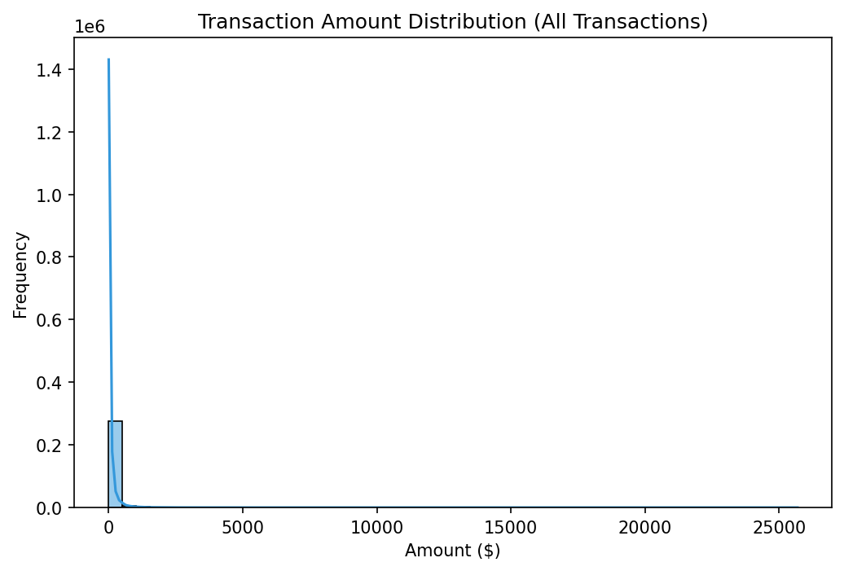
Figure 3: Overall transaction amount distribution. The heavy right skew motivated our log1p transformation.

1.1 Temporal Patterns
By engineering a cyclic hour-of-day feature from the raw Time column, we uncovered a striking pattern: fraud rates peak dramatically during nighttime hours. At 2 AM, the fraud rate reaches 1.71%, compared to below 0.05% during active daytime hours. Fraudsters exploit low-monitoring periods.
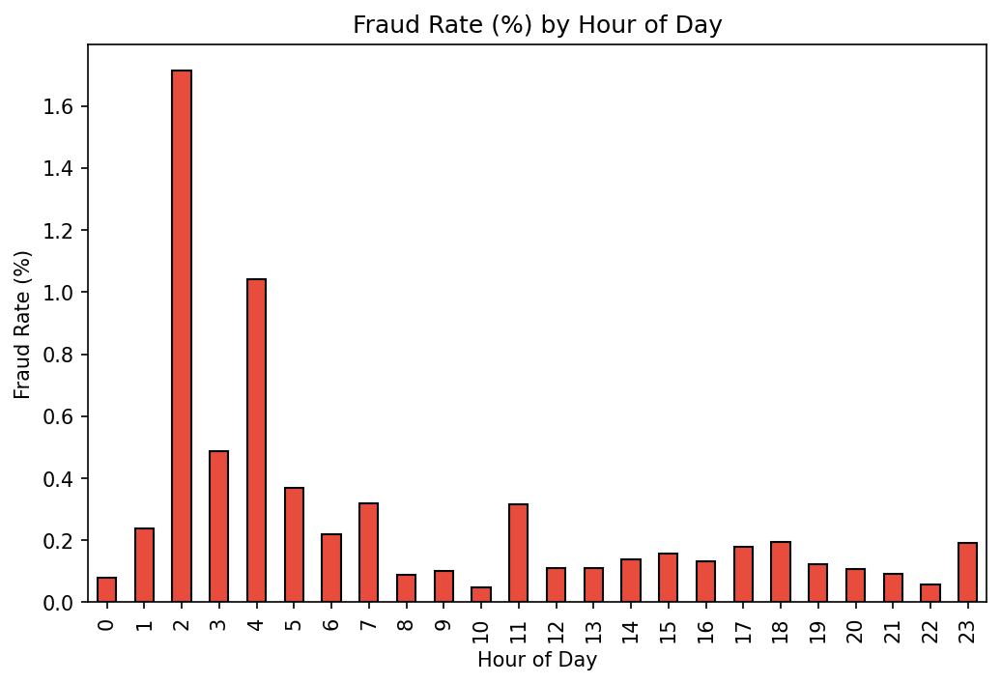
Figure 4: Fraud rate by hour of day. The 2-4 AM window shows dramatically elevated fraud incidence.
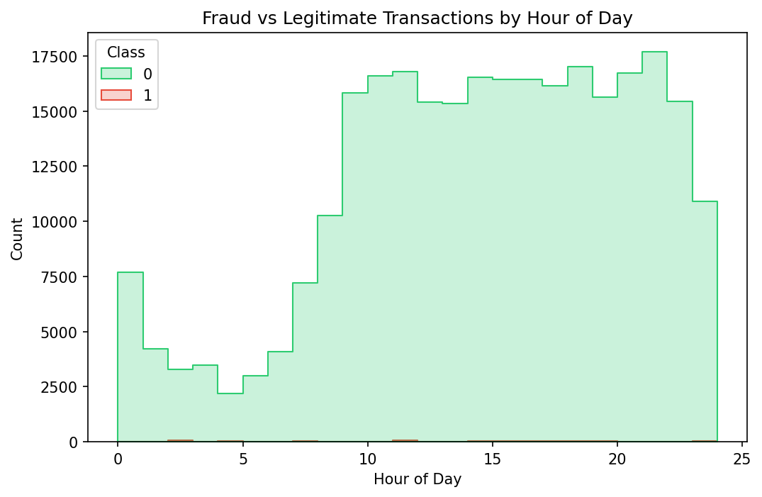
Figure 5: Transaction volume by hour and class. Legitimate traffic follows a clear day/night pattern; fraud does not.
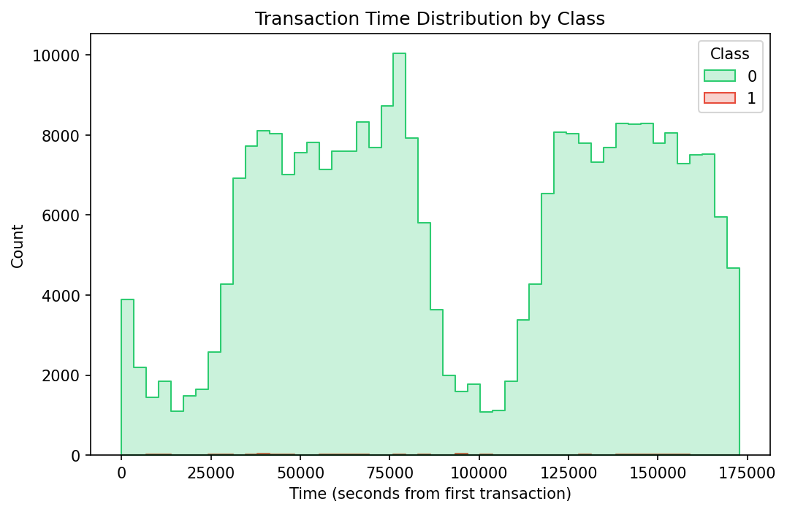
Figure 6: Transaction time distribution by class across the full observation period.
We also created a delta_time feature measuring the gap between consecutive transactions. Fraudulent transactions show a mean delta of 1.087s vs 0.606s for legitimate ones, reflecting burst-like testing patterns.
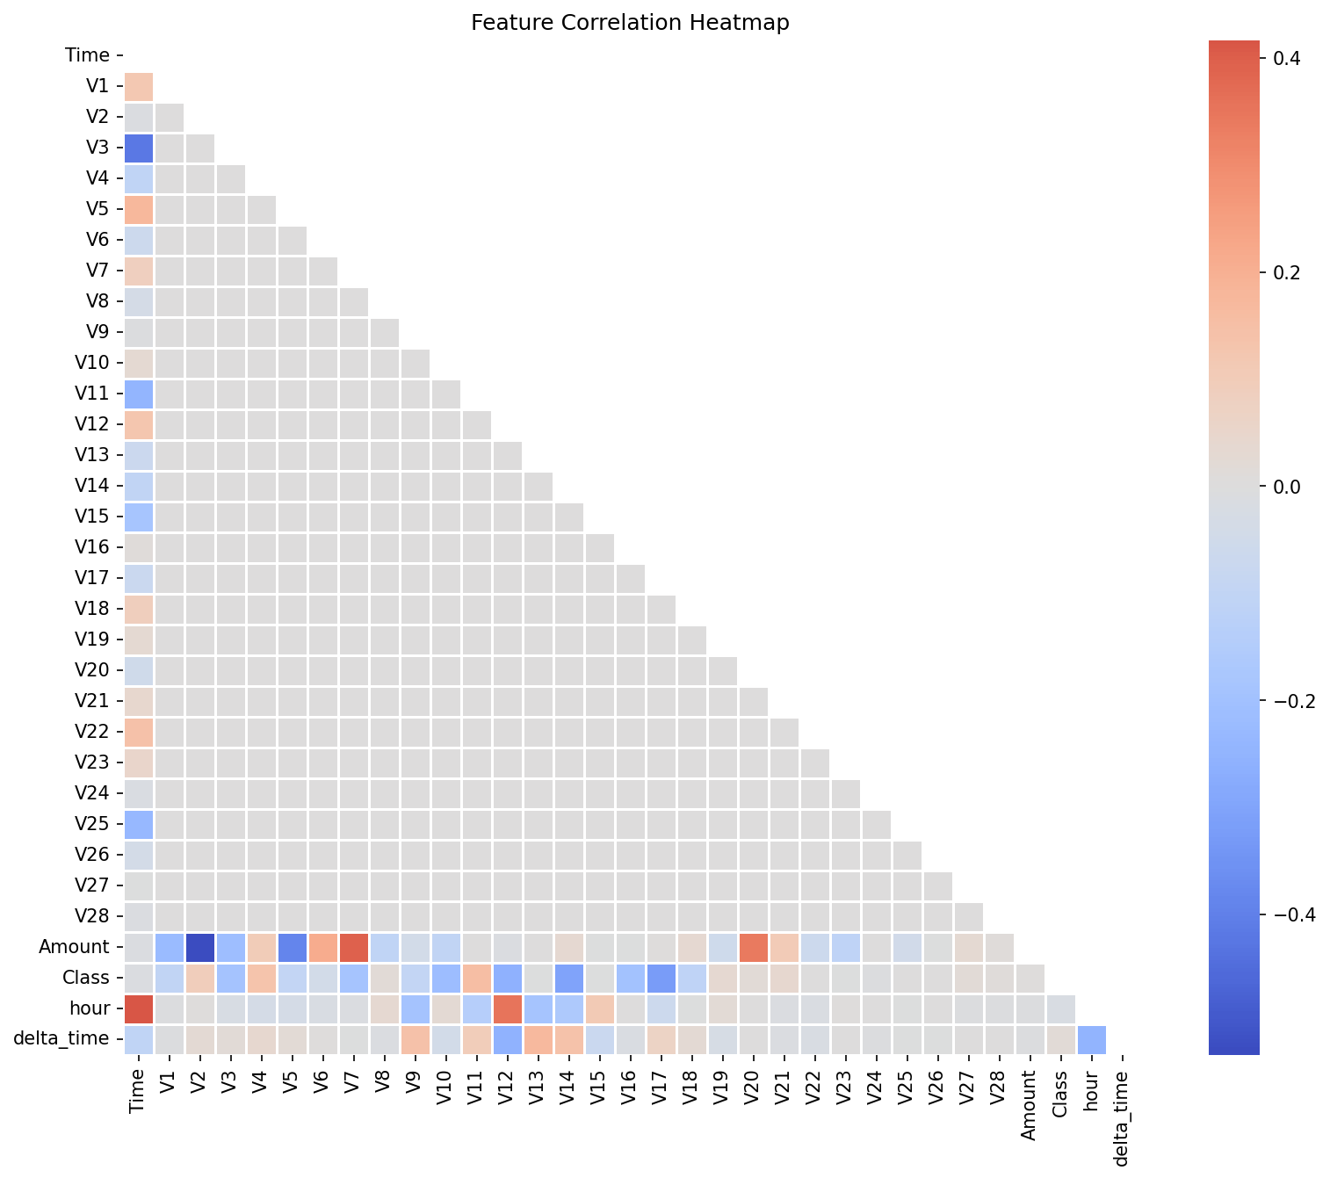
Figure 7: Feature correlation heatmap. The PCA features (V1-V28) are largely uncorrelated by design, confirming dataset integrity.

2. Revelation: Why Simple Models Fail
Our first attempt at classification used Logistic Regression with balanced class weights on an 80/20 stratified train-test split (227,845 training / 56,962 test samples, with 98 test frauds).
The logistic regression achieves an impressive ROC-AUC of 0.9712 and a recall of 89.8% - it catches most fraud. But the devastating catch is its precision: only 5.35%. For every real fraud detected, the system falsely blocks 17.7 innocent customers. It generates 1,558 false positives.
Model | ROC-AUC | Precision | Recall | F1
Naive (majority) | 0.5000 | 0.0000 | 0.0000 | 0.0000
Logistic Regression | 0.9712 | 0.0535 | 0.8980 | 0.1009
Calibrated XGBoost | 0.9855 | 0.9146 | 0.7653 | 0.8333

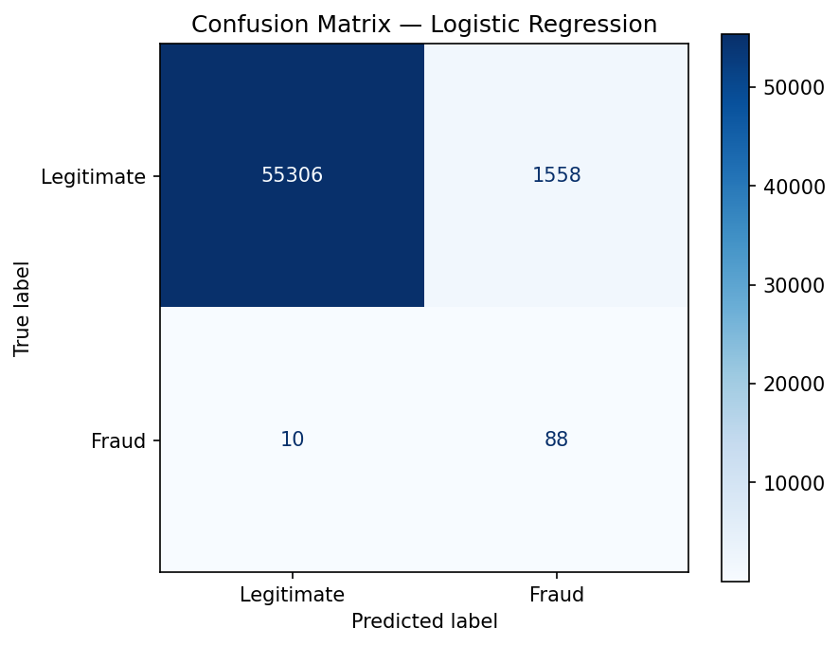
Figure 8: Logistic Regression confusion matrix. Note the 1,558 false positives (top-right cell).
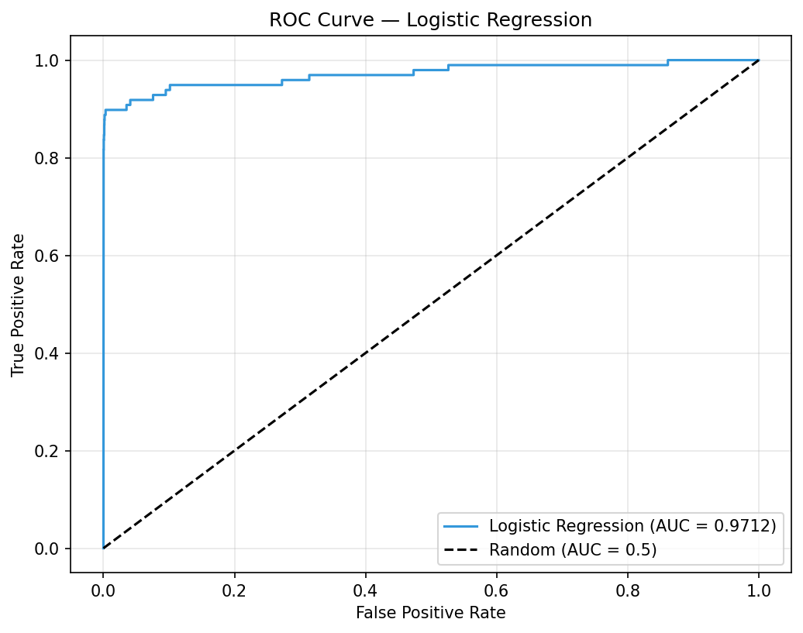
Figure 9: Logistic Regression ROC curve (AUC = 0.9712).
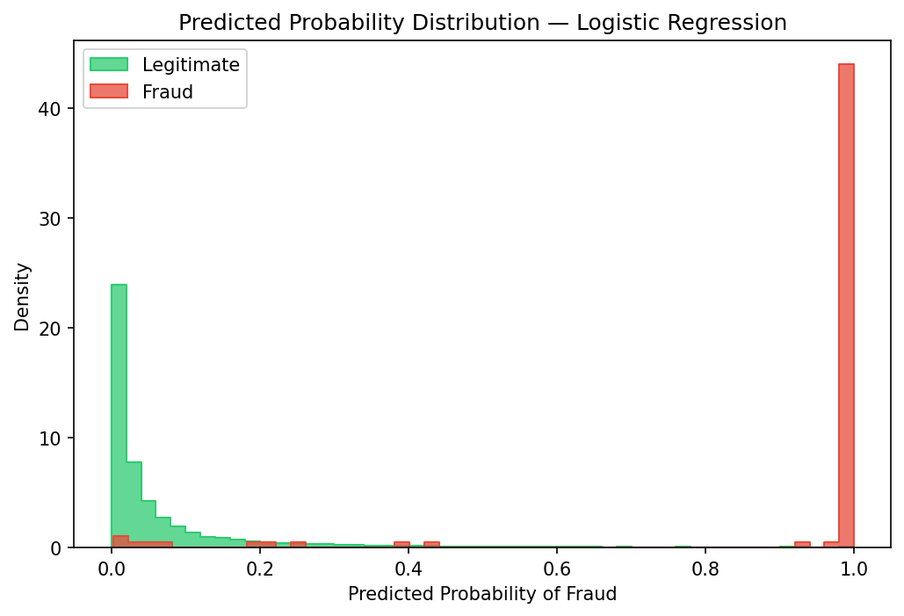
Figure 10: LR predicted probability distributions. Significant overlap between classes prevents clean separation.
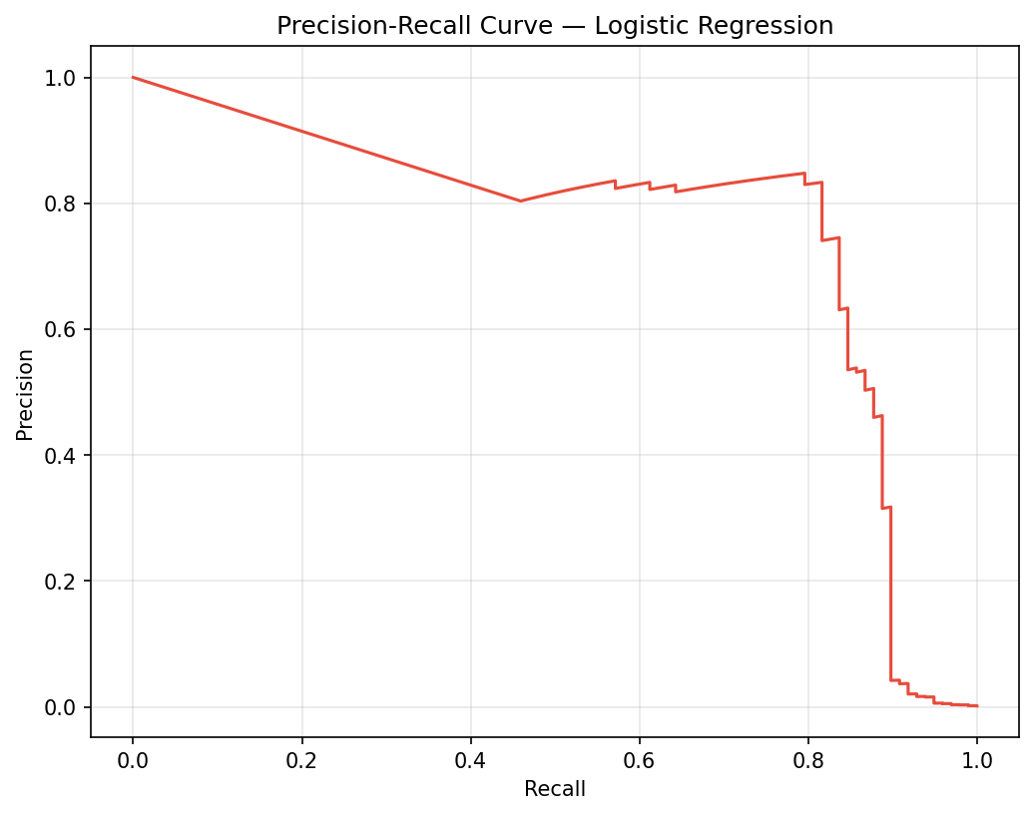
Figure 11: LR precision-recall curve showing the steep precision drop at useful recall levels.
The revelation is clear: a single threshold on a linear model cannot simultaneously achieve high precision and high recall under extreme imbalance. We need both a more powerful model AND a smarter decision framework.

3. Approach: Calibrated XGBoost & Uncertainty
We replace Logistic Regression with XGBoost gradient-boosted decision trees. Configuration: 300 estimators, max_depth=4, learning_rate=0.05, and scale_pos_weight=577.29 to counteract class imbalance. The model's raw probability outputs are then calibrated using isotonic regression with 3-fold cross-validation.
The improvement is dramatic. At a default threshold of 0.5:
- ROC-AUC: 0.9855 (vs 0.9712 for LR)
- Precision: 0.9146 (vs 0.0535 for LR - a 17x improvement)
- F1 Score: 0.8333 (vs 0.1009 for LR)
- False Positives: only 7 (vs 1,558 for LR)
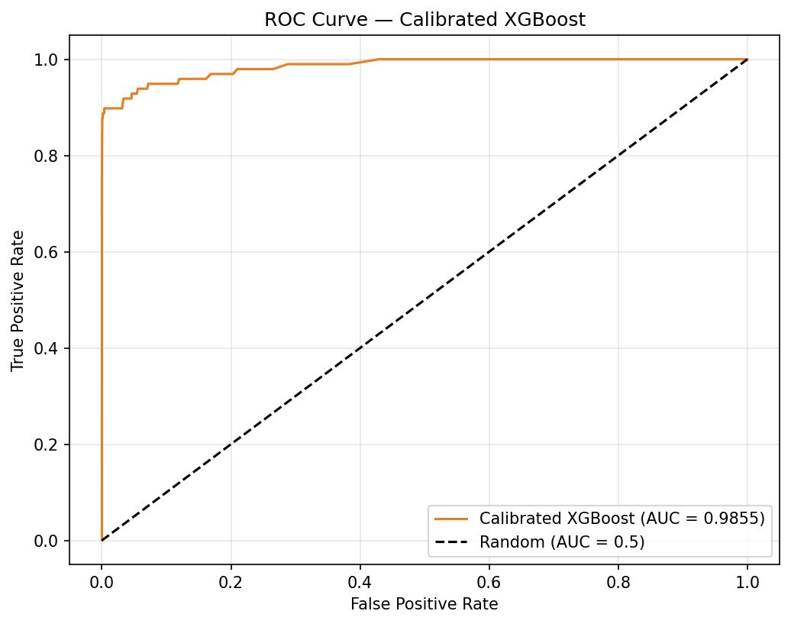
Figure 12: Calibrated XGBoost ROC curve (AUC = 0.9855) - a significant improvement over LR.
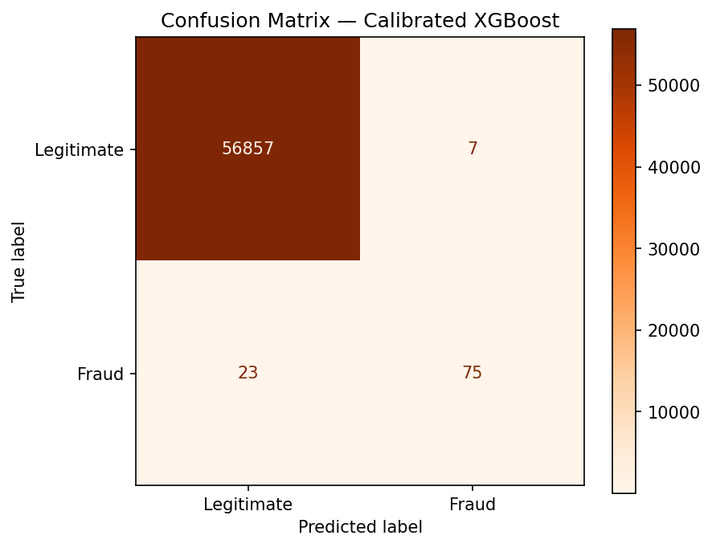
Figure 13: XGBoost confusion matrix. Only 7 false positives compared to LR's 1,558.
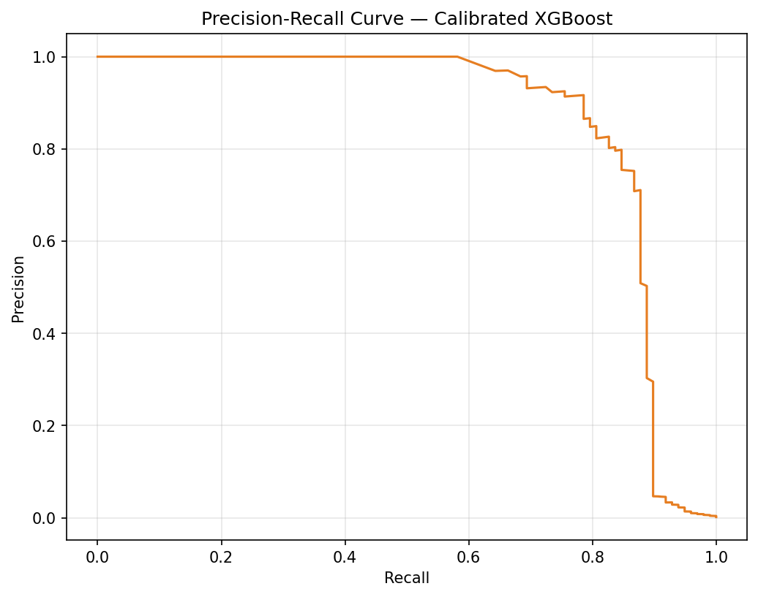
Figure 14: XGBoost Precision-Recall curve with optimal operating point at threshold 0.0707.

3.1 Bootstrap Uncertainty Quantification
A single model treats all predictions as equally confident. To quantify uncertainty, we build a bootstrap ensemble of 5 independently calibrated XGBoost models, each trained on a different random sample of the training data.
For each test transaction, the mean prediction becomes 'Risk' and the standard deviation becomes 'Uncertainty'. The ensemble achieves ROC-AUC of 0.9852, surpassing the best single model (0.9844).

3.2 Five-Fold Cross-Validation
To verify robustness, 5-fold stratified cross-validation produced:
- ROC-AUC: 0.9796 +/- 0.0056
- F1: 0.6933 +/- 0.0188
- Per-fold AUCs: 0.9777, 0.9727, 0.9886, 0.9762, 0.9826

4. Result: The 2D Risk-Uncertainty Decision Engine
The core innovation of MARI. Instead of applying a single threshold, we map every transaction into a 2D space where the X-axis is Risk (mean probability) and the Y-axis is Uncertainty (ensemble standard deviation). Three risk thresholds and one uncertainty threshold create 6 action zones:
Decision Zone | Risk | Uncertainty | Count | Fraud Rate
AUTO_BLOCK | >= 0.80 | Low | 41 | 100.0%
ESCALATE_INVEST | >= 0.80 | High | 29 | 93.1%
ABSTAIN | 0.12-0.80 | High | 28 | 50.0%
STEP_UP_AUTH | < 0.12 | High | 51 | 7.8%
AUTO_APPROVE | < 0.12 | Low | 56,813 | 0.02%

The AUTO_BLOCK zone achieves 100% fraud purity - every single transaction blocked is genuinely fraudulent. The ABSTAIN zone is the breakthrough: it captured 14 fraud cases exhibiting medium risk but high model disagreement. A traditional threshold system would have either blindly approved or rejected these. Instead, the system correctly recognizes its own uncertainty and defers to human review.
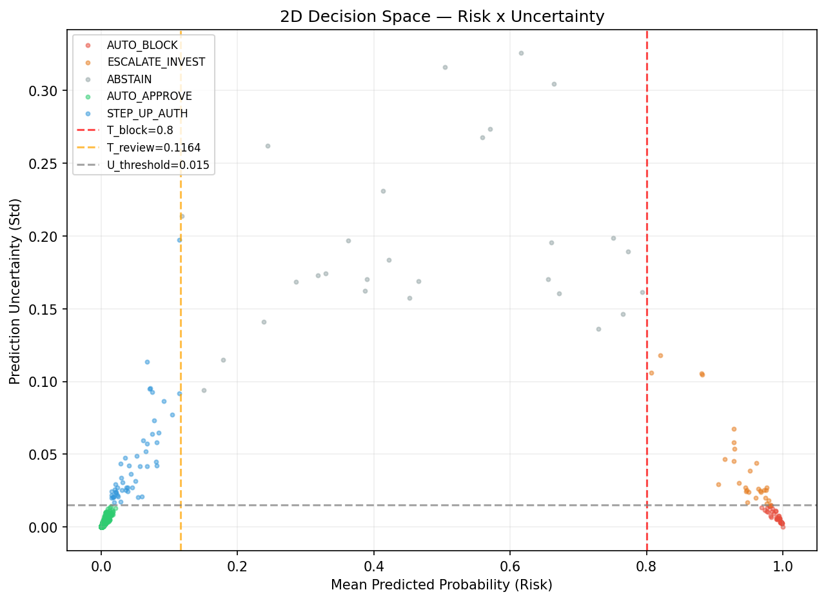
Figure 15: The 2D decision space. Each dot is a transaction, colored by assigned decision zone. Dashed lines show zone boundaries.
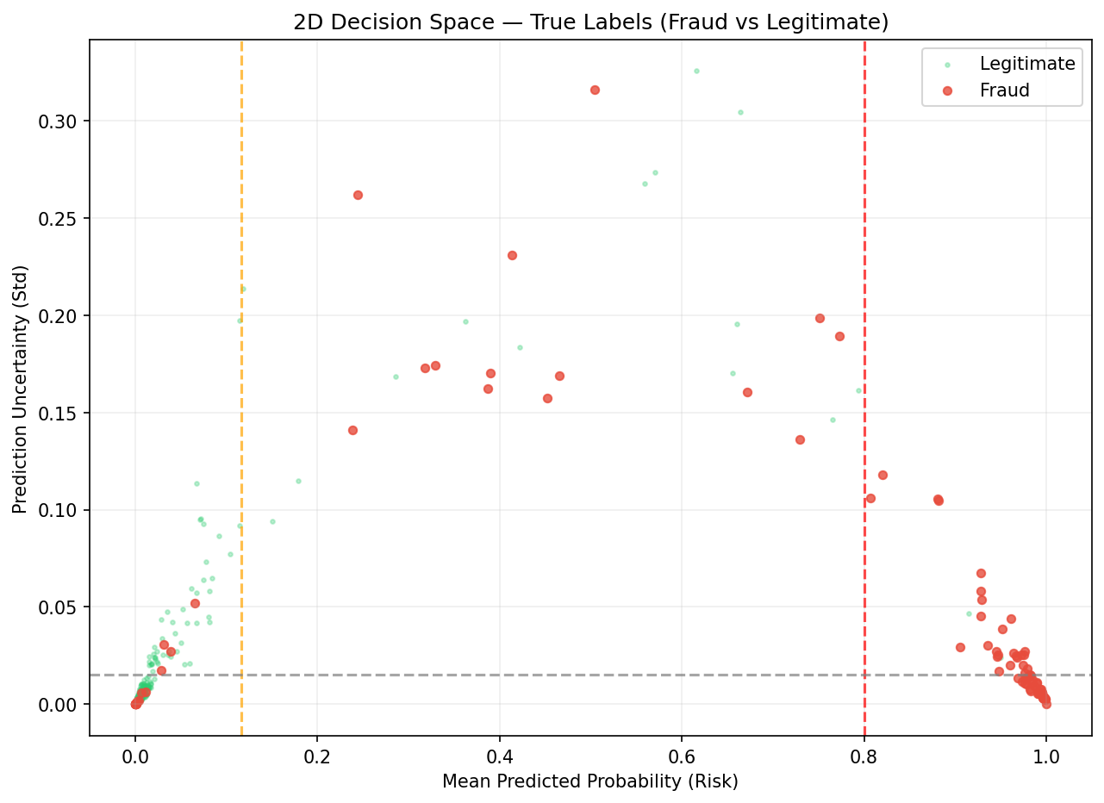
Figure 16: Same 2D space, colored by true label. Fraud (red) clusters in high-risk and high-uncertainty regions.
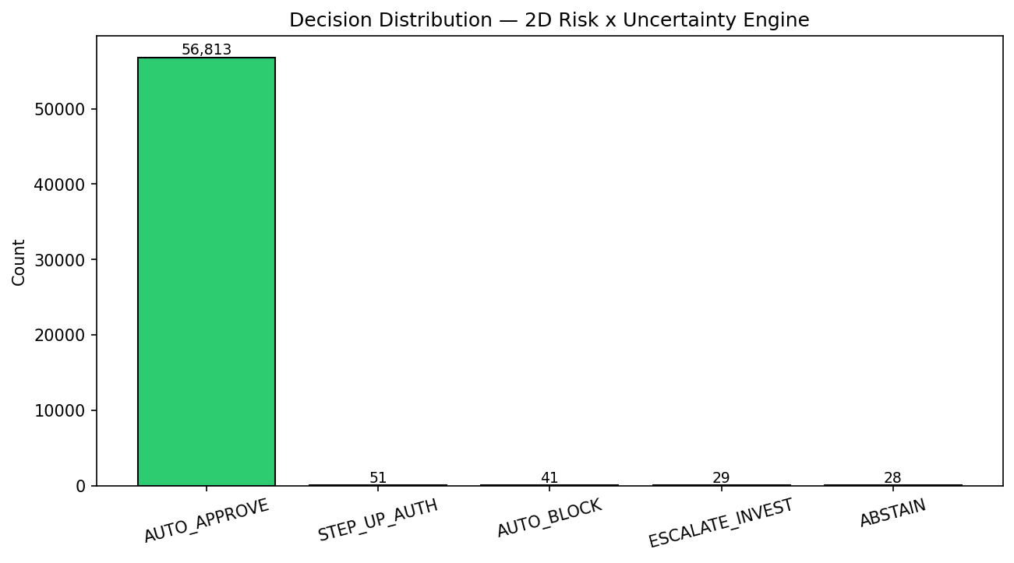
Figure 17: Decision distribution bar chart showing the vast majority of transactions are auto-approved.
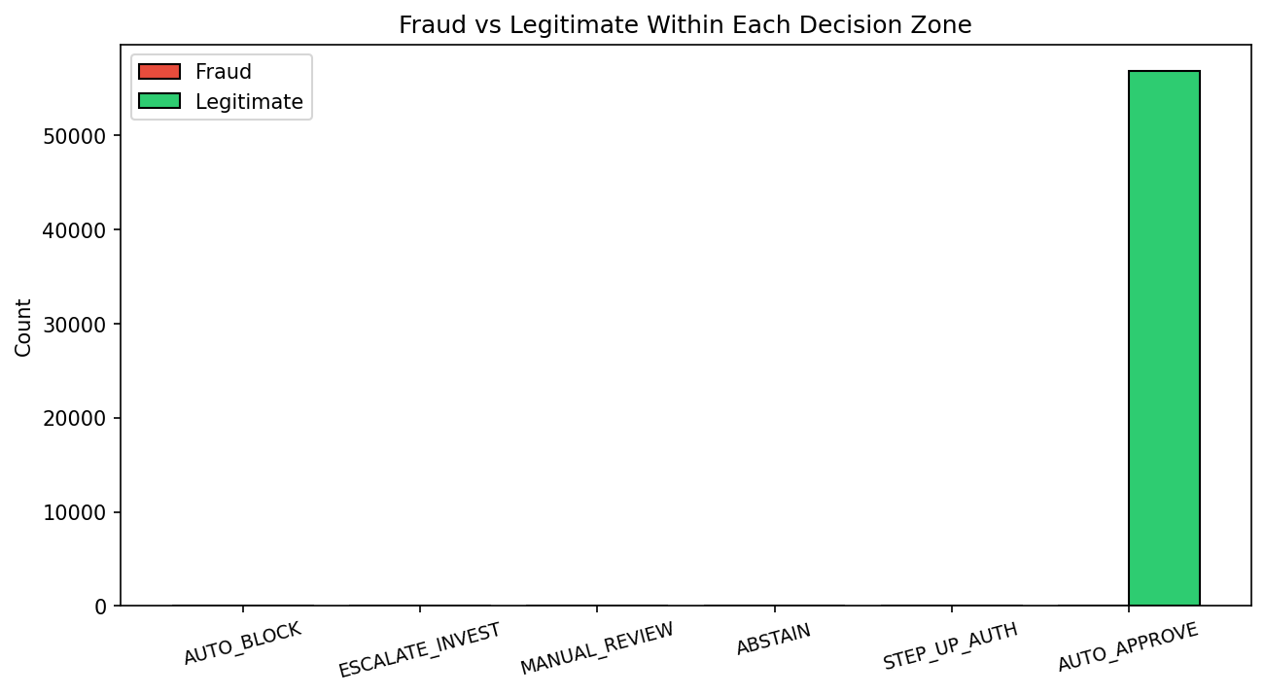
Figure 18: Fraud vs legitimate breakdown within each decision zone.

4.1 Economic Cost Analysis
Using cost parameters of $5,000 per missed fraud, $200 per false block, $100 per investigation, $50 per review, and $10 per step-up authentication:
- Total portfolio cost: $64,810
- Average cost per transaction: $1.14
- Transactions evaluated: 56,962

5. Explainability: SHAP Analysis
Every fraud decision must be explainable for regulatory compliance. Using TreeSHAP, we decompose each XGBoost prediction into per-feature contributions.
The top 5 features by mean absolute SHAP value are:
1. V14: 1.540
2. V4: 1.410
3. V10: 0.646
4. V12: 0.591
5. V26: 0.326
Our engineered 'hour' feature ranked 15th (0.183), validating our temporal feature engineering.
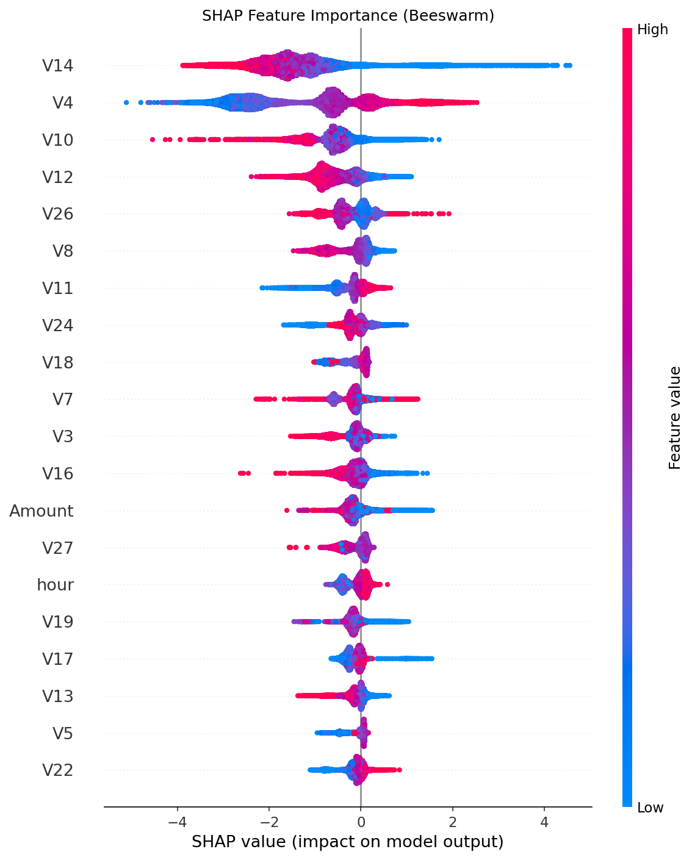
Figure 19: SHAP beeswarm plot. Each dot is a test sample; horizontal position shows SHAP value; color shows feature value. V14 shows the widest spread.
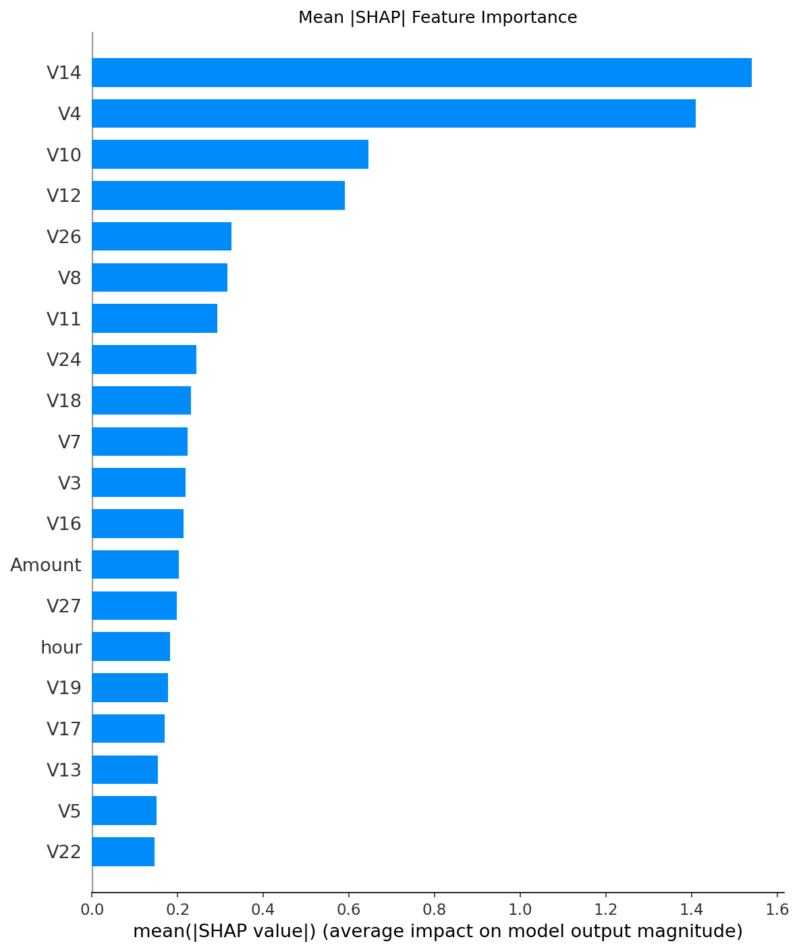
Figure 20: Mean absolute SHAP feature importance. V14 and V4 dominate decisively.

5.1 Individual Case Explanations
Force plots explain individual decisions by showing which features push the prediction toward fraud (red) or legitimate (blue).
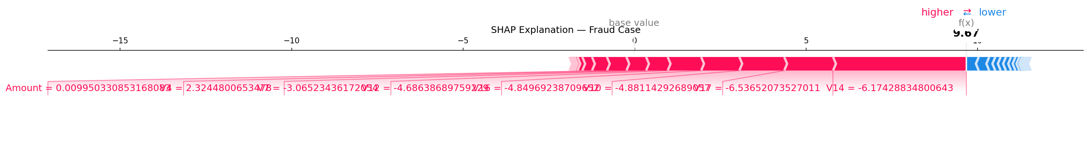
Figure 21: SHAP force plot for a confirmed fraud case. V14 and V4 strongly push the prediction toward fraud.
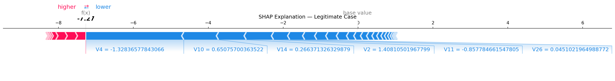
Figure 22: SHAP force plot for a legitimate transaction. Features collectively anchor the prediction near zero.
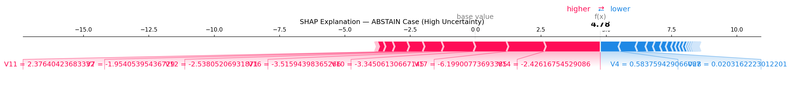
Figure 23: SHAP force plot for an ABSTAIN case. Features pull in opposite directions, creating the uncertainty that triggered system abstention.

5.2 Feature Dependence
SHAP dependence plots reveal non-linear relationships for the top features:
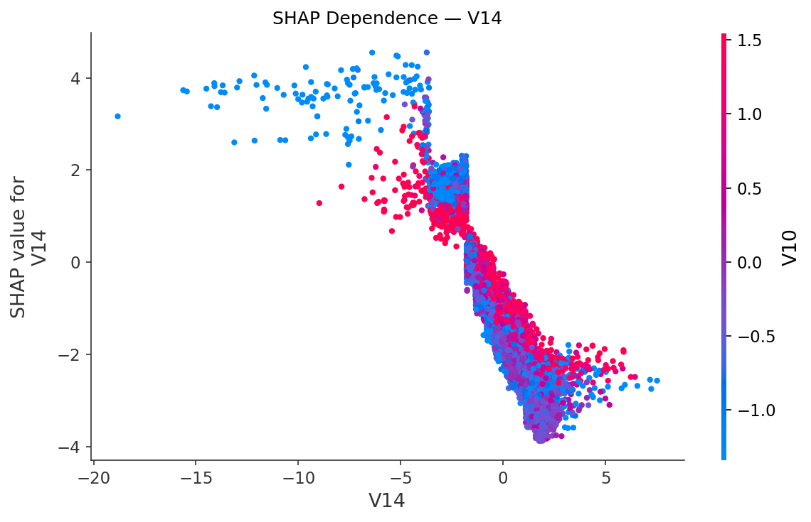
Figure 24: SHAP dependence plot for V14 showing a strong non-linear fraud signal.
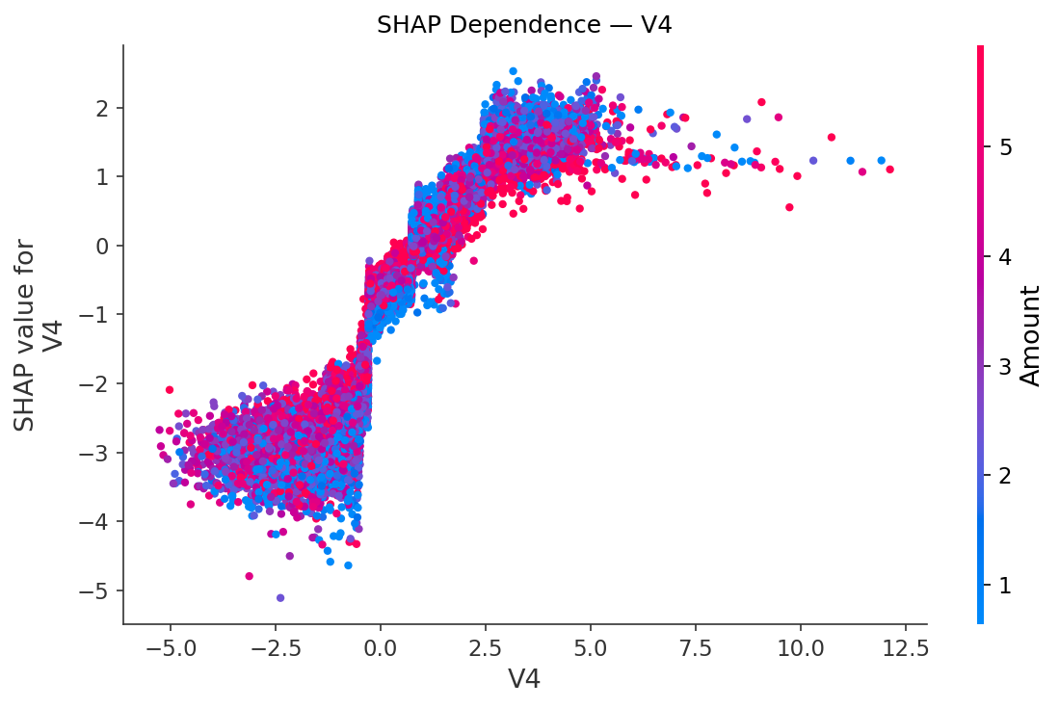
Figure 25: SHAP dependence plot for V4 showing bimodal fraud contributions.
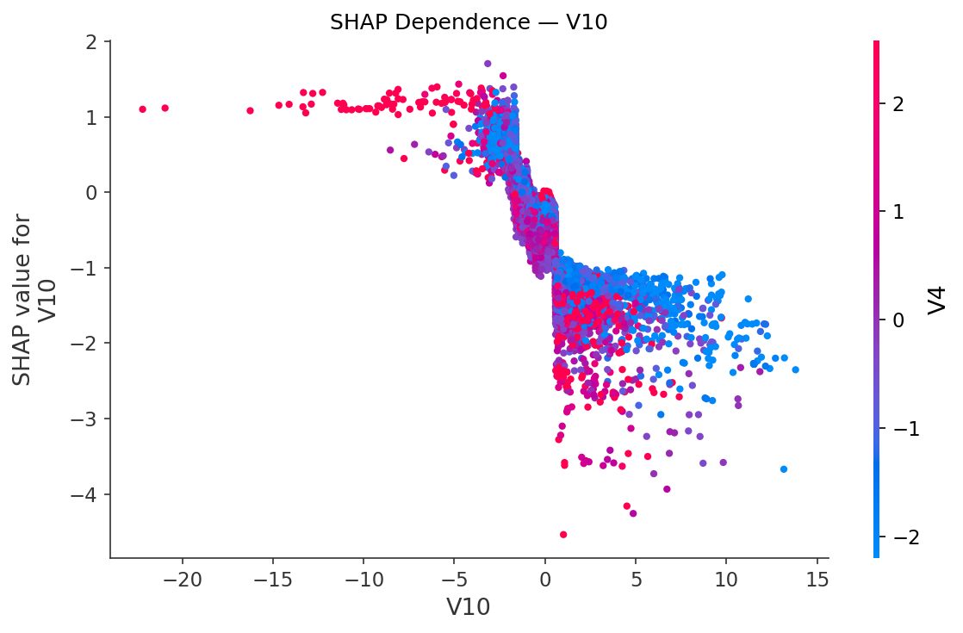
Figure 26: SHAP dependence plot for V10 - the third most impactful feature.

6. Improvement: Novelty Detection & Calibration

6.1 Isolation Forest Novelty Layer
Supervised models can only detect fraud patterns present in training data. To defend against entirely new fraud vectors (concept drift, zero-day attacks), we add an Isolation Forest trained exclusively on 227,451 legitimate training transactions with contamination=0.001.
The Isolation Forest learns the geometric 'shape' of normal behavior and flags anything that deviates:
- Mean anomaly score for fraud: -0.0746
- Mean anomaly score for legitimate: -0.2482
- Separation: 0.1736
- Standalone ROC-AUC: 0.956
Integration with the 2D engine works by upgrading decisions for anomalous transactions. AUTO_APPROVE becomes STEP_UP_AUTH, and STEP_UP becomes MANUAL_REVIEW. This mechanism flagged 623 anomalies and upgraded 561 decisions. Critically, it rescued 1 stealth fraud case that all 5 XGBoost models missed.
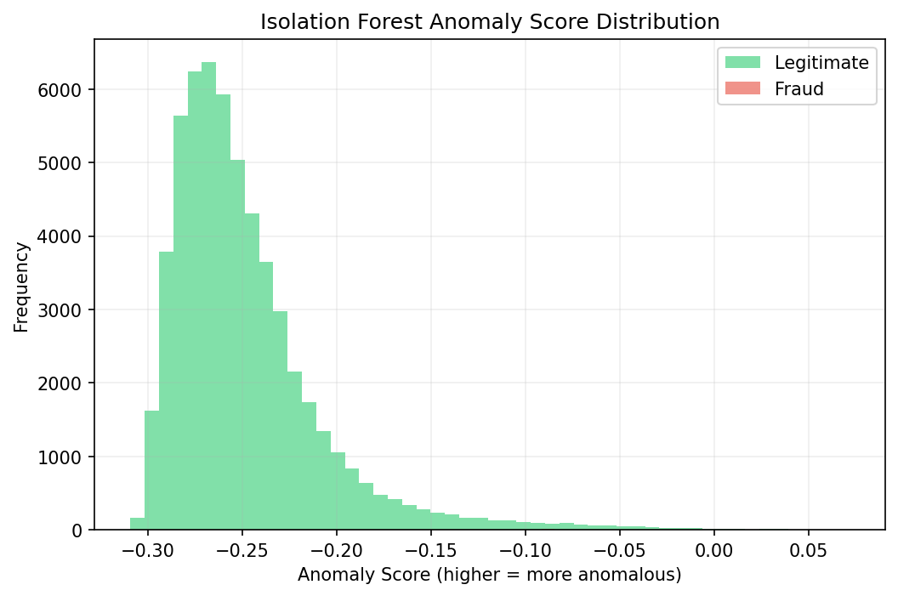
Figure 27: Isolation Forest anomaly score distributions. Fraud scores (orange) shift right toward higher anomaly.
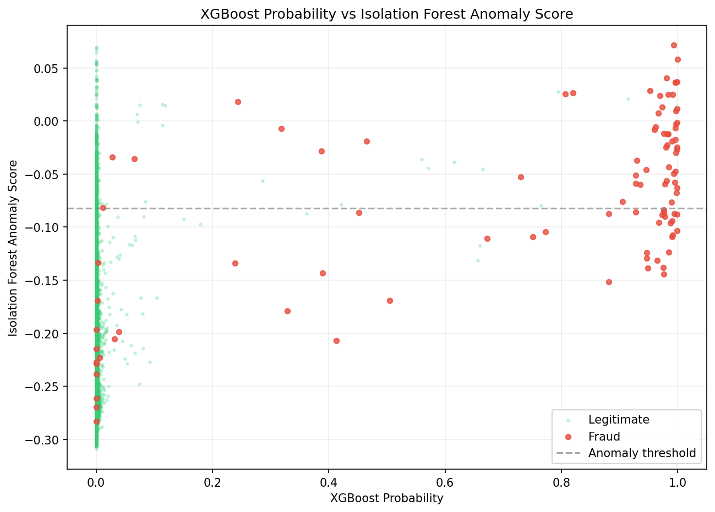
Figure 28: XGBoost probability vs Isolation Forest anomaly score. The two detection methods capture fraud on orthogonal axes.

6.2 Probability Calibration
The uncertainty engine depends on accurate probability estimates. If the model predicts '70% fraud probability,' it must literally mean 7 out of 10 such cases are genuine fraud. Isotonic calibration achieves this:
- Raw XGBoost Brier Score: 0.001758
- Calibrated XGBoost Brier Score: 0.000451
- Improvement: 74.36% reduction in calibration error
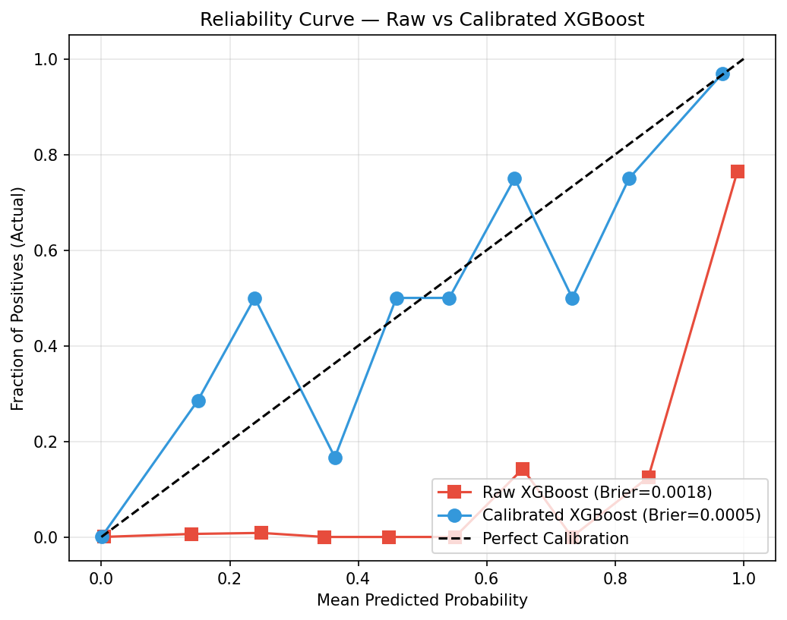
Figure 29: Reliability curve. The calibrated model (blue) closely tracks the diagonal of perfect calibration, while the raw model (red) diverges significantly.
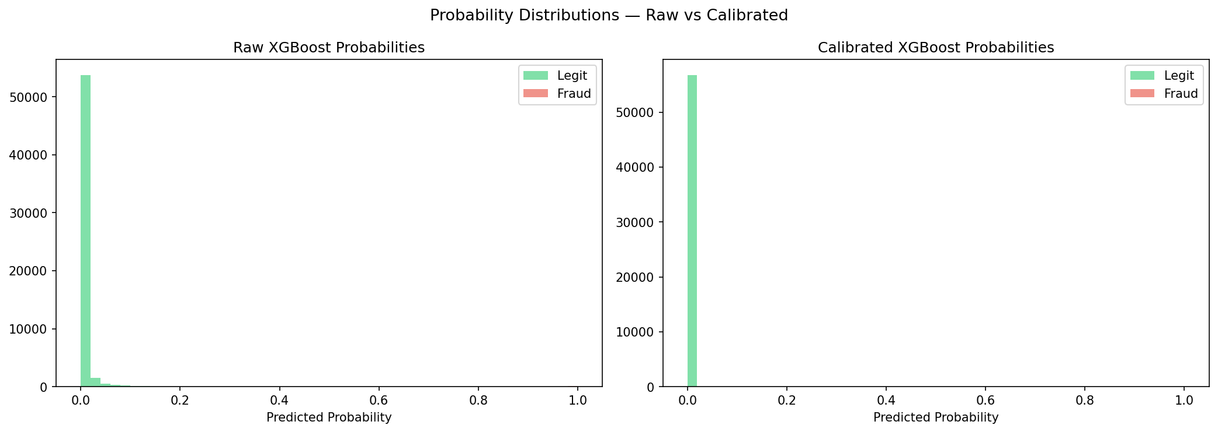
Figure 30: Probability density comparison between raw and calibrated models. Calibration concentrates legitimate predictions tightly near zero.

7. Conclusion
The MARI framework demonstrates that epistemic uncertainty is not merely a byproduct of estimation — it is a critical safety signal that warrants inclusion in enterprise decision architectures.
Key achievements:
- ROC-AUC of 0.9852 via bootstrap ensemble of calibrated XGBoost models
- 74.36% reduction in Brier calibration error via isotonic calibration
- 6-zone 2D decision engine that captures 14 'borderline' frauds via ABSTAIN
- 100% fraud purity in the AUTO_BLOCK zone
- Isolation Forest novelty layer rescued 1 stealth fraud from auto-approval
- Portfolio cost of $1.14 per transaction across 56,962 test cases
- Full SHAP interpretability for regulatory compliance
By mapping predictions into a 2D Risk x Uncertainty space, the system intelligently delegates high-variance cases to human review (ABSTAIN) while automating clear-cut decisions. The integration of SHAP interpretability ensures regulatory compliance, while the Isolation Forest provides defense against distribution shift.
Future work includes temporal modeling via LSTMs, Monte Carlo Dropout uncertainty estimation, and deployment in real-time streaming transaction pipelines.

Phase 6 Feature Analysis
Full Spoon-Feed Breakdown
The phase6_correlation_distribution.py script functions as a detective report. We have 28 mystery columns (V1–V28) and the core question is: which of these mystery columns are actually useful for catching fraud, and how useful are they? The script runs 4 types of investigation on every single column.

Investigation 1: Correlation
How related is each V column to fraud?

What We Coded
Three different correlation methods were used side by side:

Method | What It Does | Why We Used It
Pearson Correlation | Measures straight-line (linear) relationship between two numbers | The standard method. Used for Amount & Time.
Point-Biserial Correlation | Same math as Pearson, but designed for when one variable is binary (0 or 1) | Class is 0 or 1, so this is the mathematically correct method. Shows your mentor you know the difference.
Spearman Correlation | Ranks all values first, then does correlation on the ranks | Catches non-linear relationships. Immune to outliers.

What We Could Have Used Instead
- Kendall’s Tau — another rank-based method like Spearman, but slower and gives smaller numbers. Spearman is more commonly used in data science.
- Mutual Information — measures any kind of dependency, not just linear. More powerful in theory, but harder to interpret and computationally expensive on 284K rows.
- Chi-Squared Test — only works when both variables are categorical. V columns are continuous, so it doesn’t apply.

Why Pearson + Point-Biserial + Spearman Is the Sweet Spot
Using all three together enables cross-validation. If Pearson says “strong correlation” but Spearman says “weak”, it means outliers are faking the relationship. This is exactly what was caught with V7 — Pearson reported correlation with Amount at 0.40, but Spearman returned −0.03. The apparent correlation was a mirage caused by extreme values.

Investigation 2: Cohen’s d Effect Size
How separated are fraud vs. legit transactions?

What It Is in Plain Terms
Imagine lining up all legit transactions on one side of a football field and all fraud transactions on the other. Cohen’s d measures how far apart the two groups are standing, in units of “how spread out each group is.”

- d = 0.2 → The two groups are barely separated. Hard to tell them apart.
- d = 0.5 → Noticeable gap. A trained eye can tell the difference.
- d = 0.8+ → Large gap. Obvious even to a casual observer.
- d = 8.3 (V17) → The two groups are standing on completely different football fields. This feature alone practically screams “fraud.”

Why Effect Size Instead of Just Correlation
Correlation tells you direction (does V17 go up or down when fraud happens?). Cohen’s d tells you how much it shifts. A feature can have a small correlation (like V4 = 0.13) but a huge effect size (d = 3.24) because the fraud distribution is tightly clustered far away from the legit distribution.

What We Could Have Used Instead
- AUC-ROC per Feature — measures how well a single feature separates classes as a probability (0.5 = useless, 1.0 = perfect). Very popular in ML, but a single number that doesn’t tell you direction of the shift.
- KL Divergence — measures how different two probability distributions are. More theoretically elegant, but the number is hard to interpret intuitively.
- Cliff’s Delta — a non-parametric alternative to Cohen’s d. More robust with extreme skew, but less widely understood by reviewers and mentors.

Why Cohen’s d Wins
It is the gold standard in published research, directly interpretable (“the means are X standard deviations apart”), and will be immediately recognized by any mentor or reviewer.

Investigation 3: Mann-Whitney U Test
Is the difference real or just random noise?

What It Is in Plain Terms
If you flip a coin 10 times and get 7 heads, is the coin rigged? Or did you just get lucky? The Mann-Whitney U test answers the equivalent question for our data: “If fraud and legit transactions were actually identical, what’s the probability we’d see a difference this large by random chance?”
If the answer (p-value) is tiny — like p = 1.5e−260, which is 0.000…000015 with 260 zeros — the difference is definitively not random.

What We Found
- 25 out of 28 features: p < 0.05 → Statistically significant difference between fraud and legit.
- 3 features are NOT significant: V13 (p = 0.051), V15 (p = 0.130), V22 (p = 0.266) → These features are essentially noise.

Why Mann-Whitney U Instead of Alternatives
- Student’s t-test — assumes data follows a bell curve (normal distribution). Fraud data is heavily skewed with long tails, so this assumption breaks. Mann-Whitney doesn’t assume anything about the shape.
- Welch’s t-test — slightly better than Student’s but still assumes normality.
- Kolmogorov-Smirnov Test — tests if two distributions differ in any way (shape, location, spread). More general but less powerful for detecting mean shifts specifically.
- Permutation Test — the most rigorous method, but extremely slow on 284K rows.

Why Mann-Whitney U Wins
Non-parametric (no assumptions about data shape), fast, and widely accepted in statistical literature.

Investigation 4: KDE Distribution Plots
Show me the picture.

What It Is in Plain Terms
A KDE (Kernel Density Estimation) plot is a smoothed histogram. Instead of choppy bars, it produces a smooth curve showing where values concentrate. Two curves are overlaid on each subplot:
- Blue — where legit transactions live.
- Red — where fraud transactions live.
When the blue and red curves occupy completely different zones, that feature is a strong fraud detector.

What Was Added vs. the Previous Version
- Dashed vertical lines showing the mean (average) of each group.
- Stats annotation box on every subplot: Cohen’s d, correlation, and both group means — readable without referencing a separate table.

Why KDE Instead of Alternatives
- Raw Histogram — choppy, hard to compare two overlaid distributions, and bin width is arbitrary.
- Box Plot — shows median and quartiles but hides distribution shape (bimodality, tails).
- Violin Plot — similar to KDE but mirrored. Good for side-by-side comparison but clutters when overlaid.
- ECDF (Empirical CDF) — mathematically rigorous but non-intuitive for most audiences.

Why KDE Wins
Visually the clearest method for showing that two groups occupy different regions of the feature space.

Codebase Summary
What is in the repo now:

File | What It Does
phase6_correlation_distribution.py | The Python pipeline — runs all 4 investigations above.
phase6_feature_analysis_report.md | The full written report with tables and embedded plot.
distribution_analysis.png | The 8-panel KDE comparison visualization.
v1_v28_correlations.csv | Raw computed statistics for all 28 features.

Everything is committed and pushed to the v2 branch on GitHub.

